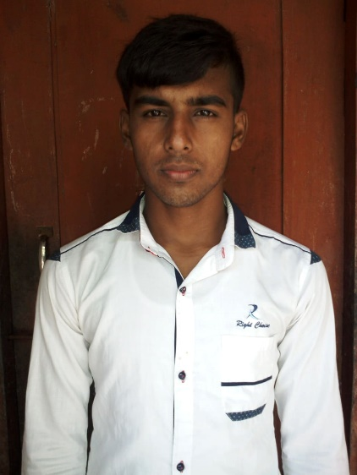

# Experience

1/12/2019 to Present

**Web Design, Bangladesh**

Cooperate with designers to create clean interfaces and simple, intuitive interactions and experiences.

* PSD to HTML. Design a website form PSD template to HTML
* UI Design (font-end).
* WordPress theme customization.

# Education

2019-Present

**Student of Department of Management, Meherpur government collage. Meherpur, Dhaka, Bangladesh**

# My Skill

* HTML 5
* CSS 3
* Bootstrap 4.4.2
* JavaScript
* jQuery
* jQurey UI
* WordPress

Biplob Shaha

**Phone:**

+88017897439657

**E-Mail:**

bipu7688@gmail.com

**Linkedin:**

<https://www.linkedin.com/in/biplob-shaha-905207191/>

**Freelancer.com:**

<https://www.freelancer.com/u/biplob8743>

# Skill Highlights

* Skill Highlights
* UI Desinger
* Creative design
* Service-focused

# Languages

Bangla

English US

Hindi (only listen and say)

**Web Desinger** specializing in front end development. Experienced with all stages of the font-end development. Well-versed in numerous font-end programming languages including HTML5, JavaScript, CSS and Wordpress(CSM).